Program/Discipline: Physical Science (Department) / Astronomy |  | Instructional Manager: Kevin Li
Semester/Year: Spring 2014 | Assessment Coordinator: Dr. Tracy Mitchell  Email: tmitchell@ccc.edu | Department Chair: Dr. Doris Espiritu
Plan Title:

Part A: Initial Plan
Part B: Midsemester Update
Part C: Further Updates

The current submission is which of the following:
□ Initial Plan date: __________

□ Mid-year update date: ________ x Final Report date: ___________

College Mission: Wright College is a learning–centered, multi-campus institution of higher education offering students of diverse backgrounds, talents, and abilities a quality education leading to baccalaureate transfer, career advancement, and/or personal development.
Program/Discipline Mission: The mission of the Department of Physical Sciences is to provide our students with solid foundations in Chemistry, Physics, and Physical Sciences so that articulation of classes and material content will allow for a seamless transition into their chosen fields of interest. Our charge is to encourage students to view physical phenomena critically and develop insights which will help them discover and understand the principles that govern events in nature. All are encouraged to develop their curiosity, enhance their intellectual skills, progressively mature, and recognize the growing role of science in society.
 |  | A. Initial Assessment Plan
Area of Focus:  Your department efforts are to improve learning in what topic/area? | Critical thinking
Evidence:  What past results have led your department to conclude that this is an area needing attention? | Wright College’s 2010 CAAP Scores indicated lower achievement in the areas of reading and critical thinking.
Course(s) of Interest:  What courses will be involved in your plan? |  |  | Astronomy 201
Intended Program Student Learning Outcomes (SLOs)  List each relevant SLO that this project pertains to. |  |  | DEPARTMENTAL SLO: Students who complete (physical) science courses at Wright College will be able to:  1) Students will demonstrate an understanding of the basic principles in the physical sciences to evaluate and solve qualitative and quantitative problems using appropriate scientific models and/or mathematical manipulations.  COURSE SLO’s: At the end of the course you will be able to do the following...  1. Describe and explain the motions of the sun, the moon, the planets, and the stars.  2. Summarize the scientific method and its application to early problems of astronomy.  3. Discuss the detection and uses of electromagnetic radiation in astronomical research.  4. Discuss the structure and formation of the solar system and its planets, major moons, comets, and asteroids.  5. Classify stars according to their luminosity and temperature.  6. Discuss the structure and evolution of stars from birth to death.  7. Describe the structure of the Milky Way galaxy.  8. Apply astronomical knowledge to example problems.
Involved Faculty:  List the instructor(s) participating in the assessment process for each outcome listed above. |  |  | Astronomy 201 Course Coordinator: Justin Lowry
Assessment/Intervention Process  Address the following questions:  What approach will be used?  Why was this process selected?  How will student learning be measured?  When will data collection be completed?  Who will analyze the results? |  |  | What: The Astronomy 201 Exit Exam is a 50-question, multiple-choice exam, prepared by the astronomy course coordinator.  Why: Each question is linked to one or more of the Astronomy 201 student learning outcomes (SLOs).  How: Student scores will be compared to the minimum passing score as well as scores from previous semesters at Wright College.  When: The exit exam is given in the 16th week (last week) of the semester.  Who: Justin Lowry, Astronomy 201 Course Coordinator
B. Midyear Update – due Oct 21
Completely describe all actions that have occurred since this past August with respect to your department’s Assessment Plan.  Attach any relative documents (rubrics, surveys, other assessment tools). |  | Not applicable.
Are there any obstacles to the implementation of the plan that the Assessment Committee should know about or can assist with? |  | No.
 |  | Part C – due TBD
Summary of Results and Analysis of Data Collected  What were the results of the assessment process?  What was learned from the results? |  | The exit exam was given to 177 students across six sections of Astronomy 201 (taught by three different instructors). Prior to taking the exam, students were informed that passing required a score of 50% (25 of 50 questions correctly answered).  Average score: 74%  Range of scores: 30% – 100%  Number of students who passed: 166 (93.8%)  Number of students who failed: 11 (6.2%)  Histogram showing number of students who scored in different percent ranges:  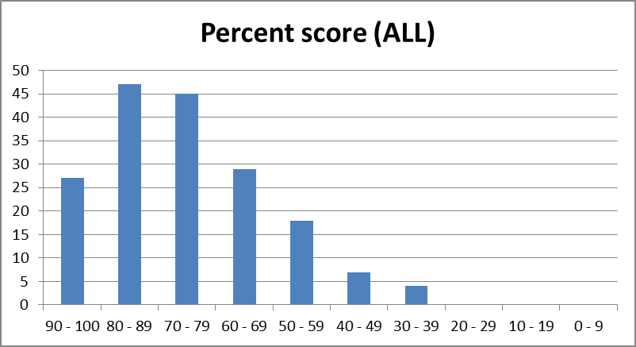
Action Plan Based on Results and Analysis  Based on what was learned, what additional steps will be taken to improve student learning? |  | In the future we will perform item analysis to determine the effectiveness of each question in measuring student learning. This will include difficulty and discrimination analysis.

