Program/Discipline: Physical Science (Department) / Physical Science |  | Instructional Manager: Kevin Li
Semester/Year: Spring 2014 | Assessment Coordinator: Dr. Tracy Mitchell  Email: tmitchell@ccc.edu | Department Chair: Dr. Doris Espiritu
Plan Title:

Part A: Initial Plan
Part B: Midsemester Update
Part C: Further Updates

The current submission is which of the following:
□ Initial Plan date: __________

□ Mid-year update date: ________ x Final Report date: ___________

College Mission: Wright College is a learning–centered, multi-campus institution of higher education offering students of diverse backgrounds, talents, and abilities a quality education leading to baccalaureate transfer, career advancement, and/or personal development.
Program/Discipline Mission: The mission of the Department of Physical Sciences is to provide our students with solid foundations in Chemistry, Physics, and Physical Sciences so that articulation of classes and material content will allow for a seamless transition into their chosen fields of interest. Our charge is to encourage students to view physical phenomena critically and develop insights which will help them discover and understand the principles that govern events in nature. All are encouraged to develop their curiosity, enhance their intellectual skills, progressively mature, and recognize the growing role of science in society.
 |  | A. Initial Assessment Plan
Area of Focus:  Your department efforts are to improve learning in what topic/area? | Critical thinking
Evidence:  What past results have led your department to conclude that this is an area needing attention? | Wright College’s 2010 CAAP Scores indicated lower achievement in the areas of reading and critical thinking.
Course(s) of Interest:  What courses will be involved in your plan? |  |  | Physical Science 101 / 111
Intended Program Student Learning Outcomes (SLOs)  List each relevant SLO that this project pertains to. |  |  | DEPARTMENTAL SLO: Students who complete (physical) science courses at Wright College will be able to:  1) Students will demonstrate an understanding of the basic principles in the physical sciences to evaluate and solve qualitative and quantitative problems using appropriate scientific models and/or mathematical manipulations.  COURSE SLO’s: The student will be able to:  1. Identify and describe the different types of rocks and minerals and how they form.  2. Describe the different ways water and ice shapes the land including through rivers, groundwater, and glaciation.  3. Describe earthquakes including their effects, the waves produced, and the identification of their location.  4. Describe and identify the different types of volcanoes and igneous intrusive features.  5. Identify and apply the methods of relative dating.  6. Identify the main components of the atmosphere.  7. Describe and relate the measures and observations relevant to Earth's weather and climate, including temperature, air pressure, humidity, clouds, and precipitation.  8. Identify and describe the primary motions of the Earth and the moon,and their effects, and compare with ancient views.  9. Describe the structure of the solar system and the nature of the planets.  10. Describe the basic nature and structure of the sun and compare to other stars.  11. Identify the main components of our galaxy.  12. Identify the basic conclusions of the Big Bang theory and its supporting evidence.
Involved Faculty:  List the instructor(s) participating in the assessment process for each outcome listed above. |  |  | Physical Science 101/111 Course Coordinator: Justin Lowry
Assessment/Intervention Process  Address the following questions:  What approach will be used?  Why was this process selected?  How will student learning be measured?  When will data collection be completed?  Who will analyze the results? |  |  | What: The Physical Science 101/111 Exit Exam is a 30-question, multiple-choice exam prepared by physical science course coordinators.  Why: Each question is linked to one or more of the Physical Science 101/111 student learning outcomes (SLOs).  How: Student scores will be compared to the minimum passing score as well as scores from previous semesters at Wright College. Item analysis will be performed to determine how well specific SLOs are being targeted and the effectiveness of each exit exam question in measuring student learning.  When: The exit exam is given in the 16th week (last week) of the semester.  Who: Justin Lowry, Physical Science 101/111 Course Coordinator
B. Midyear Update – due Oct 21
Completely describe all actions that have occurred since this past August with respect to your department’s Assessment Plan.  Attach any relative documents (rubrics, surveys, other assessment tools). |  | Not applicable.
Are there any obstacles to the implementation of the plan that the Assessment Committee should know about or can assist with? |  | No.
 |  | Part C – due TBD

Summary of Results and Analysis of Data Collected  What were the results of the assessment process?  What was learned from the results? | The exit exam was given to 220 students across nine sections of Physical Science 101/111 (taught by six different instructors). Prior to taking the exam, students were informed that passing required a score of 53% (16 of 30 questions correctly answered).  Average score: 76%  Range of scores: 33% – 100%  Number of students who passed: 204 (92.7%)  Number of students who failed: 16 (7.3%)  Difficulty and discrimination analysis was performed on all exit exam questions. Difficulty indices were found for each question by dividing the number of students who answered a question correctly by the total number of students. Simple discrimination indices were found for each question by dividing students into two groups based on their score (a top half and a bottom half) and finding the differences between the two groups. (See results below.)  Questions involving SLOs dealing with meteorology and some astronomical topics (#7, #9, and #12) seemed to suffer from lower discrimination indices and very high difficulties. The two questions with the lowest discrimination indices also suggest specific topics that are being missed (age of the Earth and erosion).  Histogram showing number of students who scored in different percent ranges:  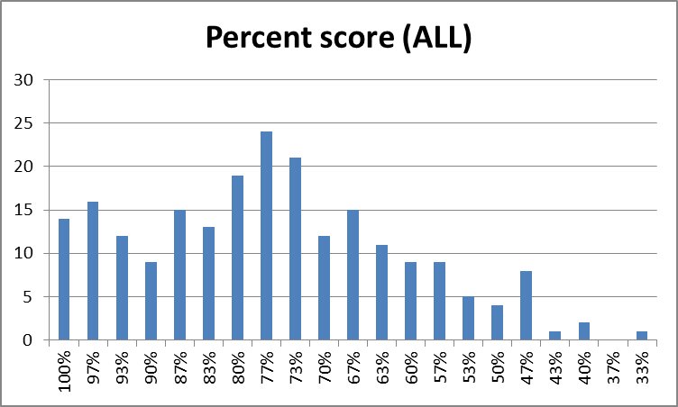  Difficulty and discrimination analysis:  Note: The item analysis does not include results from one section (comprising only 5 students).
   |  | # Correct:
  Question # | SLO # | Top Half | Bottom Half | Discrimination Index | Difficulty Index
  1 | 3 | 98 | 74 | 0.25 | 0.80
  2 | 3 | 93 | 83 | 0.12 | 0.82
  3 | 4 | 79 | 39 | 0.39 | 0.55
  4 | 5 | 90 | 45 | 0.44 | 0.63
  5 | 5 | 104 | 101 | 0.05 | 0.95
  6 | 6 | 93 | 53 | 0.39 | 0.68
  7 | 8 | 77 | 38 | 0.38 | 0.53
  8 | 7 | 103 | 87 | 0.17 | 0.88
  9 | 7 | 81 | 38 | 0.42 | 0.55
  10 | 7 | 100 | 93 | 0.09 | 0.90
  11 | 7 | 104 | 84 | 0.21 | 0.87
  12 | 8 | 88 | 63 | 0.25 | 0.70
  13 | 9 | 101 | 86 | 0.16 | 0.87
  14 | 1 | 101 | 79 | 0.23 | 0.84
  15 | 1 | 98 | 78 | 0.21 | 0.82
  16 | 1 | 94 | 67 | 0.27 | 0.75
  17 | 1 | 91 | 70 | 0.22 | 0.75
  18 | 2 | 98 | 98 | 0.03 | 0.91
  19 | 2 | 77 | 47 | 0.30 | 0.58
  20 | 2 | 86 | 60 | 0.26 | 0.68
  21 | 2 | 93 | 76 | 0.18 | 0.79
  22 | 3 | 93 | 68 | 0.25 | 0.75
  23 | 3 | 87 | 59 | 0.28 | 0.68
  24 | 3 | 89 | 41 | 0.46 | 0.60
  25 | 9 | 104 | 87 | 0.18 | 0.89
  26 | 9 | 92 | 82 | 0.12 | 0.81
  27 | 10 | 89 | 64 | 0.25 | 0.71
  28 | 10 | 103 | 81 | 0.23 | 0.86
  29 | 10 | 97 | 67 | 0.30 | 0.76
  30 | 12 | 101 | 86 | 0.16 | 0.87
Action Plan Based on Results and Analysis  Based on what was learned, what additional steps will be taken to improve student learning? | Based on the above item analysis, instructors may need to devote more time to topics relating to the solar system and meteorology. Two specific items require special attention: the age of the Earth and the concept of erosion. These are basic questions which should not have high difficulties. Other questions indicating poor discrimination may warrant further analysis regarding their effectiveness in measuring student learning.  The SLOs were recently revised (Fall 2013) to provide a more compact list. In performing this analysis it has become apparent that our exit exam does not address SLO #11 (components of our galaxy). Furthermore, there are topics on the exit exam that only loosely tie to the SLOs as stated (specifically topics related to plate tectonics). In this case, I believe we need to revise or add an SLO in the future.

