Program/Discipline: Biology |  | Instructional Manager: Kevin Li
Semester/Year: Fall 2013 | Assessment Coordinator:  Email: jhogan21@ccc.edu | Department Chair: Alicia Anzaldo
Plan Title: Clicker Assessment

The current submission is which of the following:
□ Initial Plan date: __________

□ Mid-year update date: ________ □ Final Report date: _Nov 25th , 2013_____

College Mission: Wright College is a learning–centered, multi-campus institution of higher education offering students of diverse backgrounds, talents, and abilities a quality education leading to baccalaureate transfer, career advancement, and/or personal development.
Program/Discipline Mission: The mission of the Biology Department is to open doors to the future for our students. To accomplish this mission the curriculum is designed and organized to prepare competent and effective students who can use biological principles and who can critically think, read, and demonstrate quantitative and technological literacy. With these skills, biology students can successfully achieve their life goals and make informed judgments concerning the medical and environmental worlds.
 |  | A. Initial Assessment Plan
Area of Focus:  Your department efforts are to improve learning in what topic/area? | Improving active learning in the classroom  Improving student achievement of SLOs
Evidence:  What past results have led your department to conclude that this is an area needing attention? | Biology 121 has a high drop rate for students.
Course(s) of Interest:  What courses will be involved in your plan? |  |  | Biology 121
Intended Program Student Learning Outcomes (SLOs)  List each relevant SLO that this project pertains to. |  |  | - Communicate the characteristics of life present in all life forms  - Explain concepts relating to energy transformation in life forms
Involved Faculty:  List the instructor(s) participating in the assessment process for each outcome listed above. |  |  | Jennifer Hogan
Assessment/Intervention Process  Address the following questions:  What approach will be used?  Why was this process selected?  How will student learning be measured?  When will data collection be completed?  Who will analyze the results? |  |  | What: Use of clickers in the classroom  Why: To improve active learning and help students achieve the student learning outcomes  How: Compare scores of specific test questions between a class that did not use clickers in the classroom and two classes that did use clickers in the classroom prior to the test.  When: Fall 2013  Who: Jennifer Hogan
B. Midyear Update
Completely describe all actions that have occurred since implementation of your department’s Assessment Plan.

Attach any relative documents (rubrics, surveys, other assessment tools).

Are there any obstacles to the implementation of the plan that the Assessment Committee should know about or can assist with? |  | Variables:  Within my summative assessment there are many variables that are worth addressing. First and foremost, as mentioned and seen above, summer classes typically have a greater class performance than fall classes. This could be attributed to the fact that a large number of new students begin school in the fall semester and have not quite adjusted to the requirements of college-level courses. It is also more likely that summer students either have been exposed to the material because they were enrolled in the course in a previous semester, or were exposed to the rigor of college-level courses because they have taken other classes either at Wright College or another college.  Even if there was not a difference in semesters, each class itself has a unique form and character, which makes it difficult to accurately compare two or more classes. Furthermore, these three classes were all taught over a different amount of days per week. The Summer AB2 class met four times per week, the Fall HJ class met twice per week, and the Fall UVW2 class met once per week. The amount of material covered in each class as well as time between each class session was significantly different, which added an additional variable to the assessment. The Summer AB2 was condensed. This makes the course challenging, but this can also be advantageous because the content was fresh in students’ minds and less likely to be lost throughout the week. The Friday class (Fall UVW2) had the most difficult situation because they were introduced to new material over a five and half hour class, and we did not meet again to discuss the material for an entire week. This required a longer attention span and greater self-discipline for students who only have the class once a week.  Student absence and non-participation in clicker questions further complicated the data. These students did not participate in the formative assessment, and yet, still took the test and were accounted for in the summative assessment. This could skew the test results to some degree.  A final variable to mention is that this summer was my first semester teaching this course, and I know I have made changes and improvements to this course this semester. This variable is in favor of the fall classes though, who did show much or any improvement with the use of clickers.  Due to my students’ satisfaction with clickers, the supporting evidence of larger studies, and the formative assessment benefits I found in using clickers, I am going to continue implementing clickers as an assessment tool in hopes of finding better summative results with additional applications. However, clickers will not improve classroom success unless used appropriately to compensate areas of weakness and address specific objectives (Caldwell, 2007). Thus, the choice to continue using them is not made without addressing ways to adjust this assessment tool to improve student learning. This is discussed below.
 |  | Part C
Summary of Results and Analysis of Data Collected  What were the results of the assessment process?  What was learned from the results? |  | Results  The first column of the table below shows the average percent of correct answers to all 12 questions on Test #2 for each class (Summer AB2, Fall HJ, and Fall UVW2). The second column shows the class average of the entire test in order to show the relative strength of that particular class compared to other classes. The second table shows the results for Test #3. To see specific questions asked, percent correct on individual questions, as well as the clicker questions and performance, please view the assessment data at the end of this section.  “Clicker Questions”= Questions on the exam that were matched to questions asked using clickers in the classroom.  Test #2:  Looking at the classes collectively:  The Summer AB2 class performed better on both the entire Test #2 (column 2) as well as the 12 questions matched to clicker questions (column 1) compared to the two Fall classes. I have been told that summer classes tend to generally perform better than fall classes. This could very well be a large variable, in addition to the fact that each class of students can be very different. Therefore, it may be more accurate to look at the class performance on those 12 test questions relative to the individual class average for the entire test. This is analyzed below.  Looking at classes individually:  Summer AB2- No change. The Summer AB2 class' percent correct of the 12 questions was representative of the class average for the entire test (both 67%).  Fall HJ- Performed better on 12 “clicker questions” compared to overall test. The Fall HJ class did better on the 12 questions that correlated to clicker questions (61%) compared to their overall test average (59%).  Fall UVW2- Performed worse on 12 “clicker questions” compared to overall test. The Fall UVW2 class did worse on the 12 questions that correlated to clicker questions (60%) compared to their overall test average (64%).  Test #3:  Looking at the classes collectively:  Again, the Summer AB2 class performed better on both the entire Test #3 (column 2) as well as the 11 questions matched to clicker questions (column 1). As mentioned above, it may be more fruitful to look at the classes individually.  Looking at the classes individually:  Summer AB2- Performed better on 11 “clicker questions” compared to overall test. The Summer AB2 class did better on the questions that correlated to clicker questions (71%) compared to the average of their entire exam (66%).  Fall HJ - Performed better on 11 “clicker questions” compared to overall test. The Fall HJ class again did better on the 11 questions that correlated to clicker questions (67%) compared to their overall test average (65%).  Fall UVW2- No change. The Fall UVW2 class performed just as well on the 11 questions that correlated to clicker questions compared to their overall test average (both 63%).  Discussion  Though no statistics have been applied, it looks as though there is little to no correlation between test scores and clicker use. The Summer AB2 class performed the same or better than other classes on the specific “clicker questions” even though they did not use clickers. The Fall HJ class performed better on the questions designated as clicker questions for both exams, though the improvement was an insignificant 2%. The Fall UVW2 performed the same or worse on the clicker questions than they did on the overall test, even though they were presented with similar questions in class using the clickers.  This summative assessment does not support the use of clickers for test score improvement. However, a majority of my students enjoyed using them. Their satisfaction with clickers may correlate with increased active learning. Near the end of the semester, I asked my students questions regarding their preference for clickers in both my Fall HJ and Fall UVW2 sections. The results (see Figure 1 and 2 below) were impressive, indicating that a majority of students support the use of clickers in their classroom learning environment.  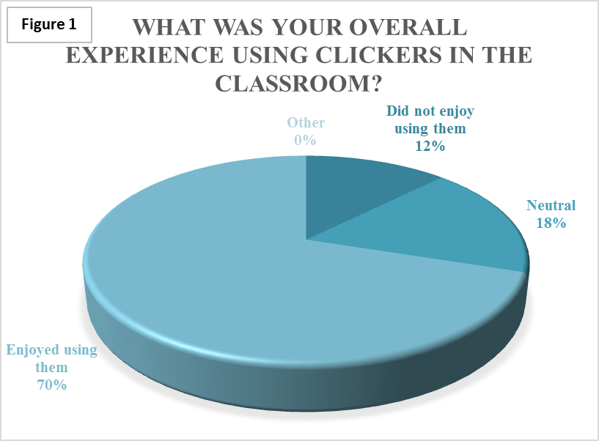  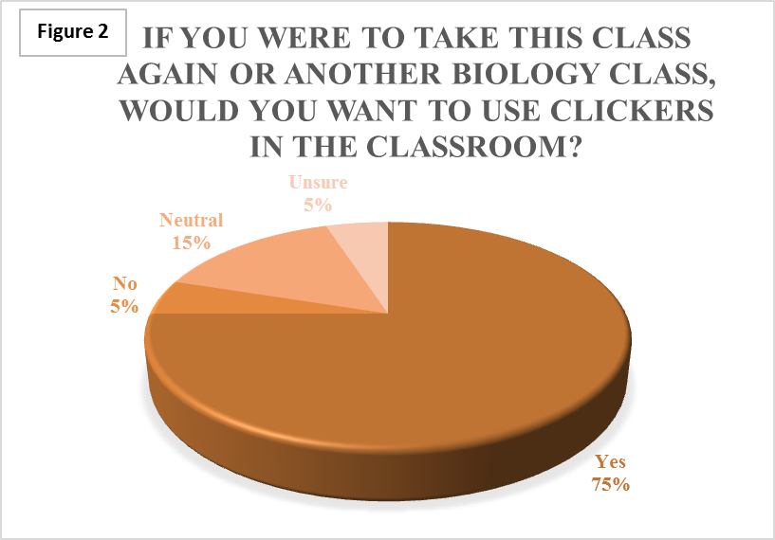  These results are not surprising, as research shows there is a general consensus that students and teachers like using clickers. A collection of research and reviews further supports the use of clickers for increasing active learning, student attendance, and test scores. There is not strong scientific data that explains how clickers provide these benefits, but there are many recommendations on how to utilize them for maximum results (Caldwell, 2007). Many of these suggestions are mentioned in the last section of this assessment (Closing the Loop) as changes I plan on making to improve the implementation of clickers.
  Test #2 | Percent correct of 12 "Clicker Questions" on Test | Class average of Entire Test |  | Test #3 | Percent correct of 11 "Clicker Questions" from Test | Class Average of Entire Test
  Summer AB2  n=31  (no clickers) | 67% | 67% |  | Summer AB2  n=29  (no clickers) | 71% | 66%
  Fall HJ  n=33  (Clickers) | 61% | 59% |  | Fall HJ  n=31  (Clickers) | 67% | 65%
  Fall UVW2  n=32  (Clickers) | 60% | 64% |  | Fall UVW2  n=27  (Clickers) | 63% | 63%
Action Plan Based on Results and Analysis  Based on what was learned, what additional steps will be taken to improve student learning? |  | An assessment is not complete until the information gained from it has been used to change or support future actions. Here I would like to discuss how this assessment will inform my teaching.  Because this is my first semester using this assessment tool, there is room for improvement in order to obtain the greatest outcomes. Some of these changes have already been made throughout this current semester. For example, I started including a timer for clicker questions so we could maintain an appropriate pace in the class. I have edited or removed poorly worded questions or questions that go far beyond the scope of this course. Near the end of the semester, I have also searched for more resources to develop strong clicker questions, including more questions with pictures and diagrams.  From both my personal reflection and Jane Caldwell’s research I have a number of suggestions for improving the application of clickers that I plan on focusing on next semester. These are listed below:  - Integrate the questions into lectures more smoothly. Asking clicker questions at the right time and preparing my students appropriately for those questions will capitalize on the use of this tool.  - Explain to students why we are using the clickers so they are aware of their purpose and my expectations (Caldwell, 2007).  - Incorporate peer learning. Some instructors ask questions twice, allowing students to discuss the question with each other before answering the second time. This approach to learning has shown to improve student performance compared to traditional lecture (Caldwell, 2007).  - Be more prepared to spend time discussing answers to questions (Caldwell, 2007). Accounting for the time that clickers take out of a traditional lecture was something I did not prepare for at the beginning of the semester. Now that I am aware of that I can structure lecture to allot the necessary time for discussion of the questions. Without this discussion, a large aspect of the formative assessment is lost.  - Make clicker questions worth more of their overall class grade. Studies show that when they are worth at least 10% of the grade it increases attendance (Caldwell, 2007). I think this would be an additional motivator to perform well and invest energy during class.  - Make students’ clicker score easily available to them (Caldwell, 2007). I will be setting up the TurningPoint system so that the students’ scores are immediately reported on BlackBoard. I think it would be beneficial for students to see how well they have been doing on clicker questions throughout the semester. This can serve as another checkpoint for them to assess their status in the class, encouragement to actively participate in the clicker questions, and incentive to be present and on time to class.  - Give partial credit for just answering the question (Caldwell, 2007). This supports student attendance and reduces anxiety.  - Improve the questions asked. This would entail addressing common misconceptions students have coming into the course, relating new material to a concept they have already learned (Caldwell, 2007), including “I don’t know” answer choices (Wit, 2003), and incorporating more application or critical thinking questions. I would also like to improve this assessment so that I am asking questions related to certain topics that can correlate to test questions and, yet, not be identical to the test question. “There is a general agreement that a good clicker question is different from a good exam question . . .” (Caldwell, 2007). My understanding is that clicker questions should be targeted at producing a variety of responses to generate discussion and eradicate misconceptions. Test questions are not necessarily designed for discussion. Also, if the questions are too similar, then there is the additional variable that students get the question correct on the exam because they have simply seen the question previously.  - Use clickers to prepare for lab activities. I started to do this near the end of the semester and found this to be very fruitful. Using clickers for labs makes students more accountable for the lab information, and I can assess how prepared they are for lab. As a result, we can make the lab activity more efficient and effective.  In conclusion, my experience using clickers in the classroom as both a formative and summative assessment was positive and worthwhile. Though the data from the summative assessment did not show a significant improvement in students attaining the specific student learning outcomes as measured by test scores, I saw benefits elsewhere. I was able to more accurately assess the percentage of students in the class who understood certain concepts, which allowed me to adjust my teaching appropriately on the spot. I also found that a majority of my students enjoyed using clickers in the classroom, which is a qualitative measure that supports student learning. I plan to continue using this assessment tool, making improvements along the way, and collecting a larger sample size in hopes of finding more quantitative summative data regarding the use of clickers.

