Link from Assessment Plans Plan all pages

Best Practices in Assessment
How to Improve Student Learning and Increase Student Success

- Make a Plan

Use the included template and rubric to create a plan for assessing student learning at the department level. A good plan will:

  - Identify specific student learning outcomes
  - Identify the instrument(s) to measure student achievement of the outcomes
  - Give a timeline for when and how the results will be collected
  - Plan for how the results will be used

- Create the instrument(s) and implement the plan

- Collect and analyze the data

Use the included template and rubric to report the status of your plan, any data that has been collected, what that data means to you in terms of student learning, and how you might change things to improve student learning where necessary.

- Implement the changes in your course(s) or department.

- Repeat steps 3 and 4 on an ongoing basis. Are there trends in the data? What effects did the changes make, if any?

- Modify the plan as needed to address challenges and improve the process.

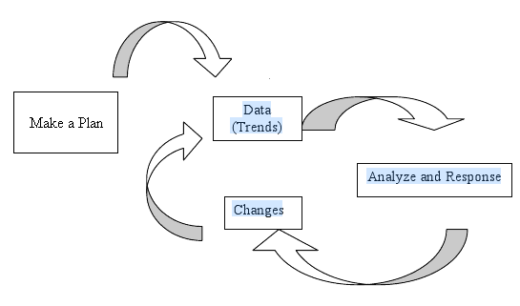

Assessment Plans sub link Step 1

Department and Program Assessment Plan Template

- Mission statement of department and program.

- The SLOs that are to be assessed. These can be course-level or department/program-level.

- How will you determine if these SLOs are being met? Where will the data come from? (Examples: pre/post-tests, portfolios, papers, surveys, focus groups, standardized tests, etc.)

- How will you score/judge the assessments? (Here you would include rubrics, computer programs, etc.)

- How will you use this data? In other words, what is the purpose of this assessment? What are you trying to learn and for what purpose?

- What is your timetable for this assessment? What will be your timetable for doing assessment in the future?

Department Assessment Plan Progress Reporting Template

- Have you substantially changed the plan? If so, in which areas? Please refer to sections 1-6 in the DAP template.

- Have you implemented, or begun to implement, the plan? If so, what steps have been completed as of the date of this report?

- Have any results, (i.e. data) been generated? If so, present the data:
(this is an example of how you might present the data)
SLO | % achieved  (pre/post, if appropriate) | Threshold met?  Yes or no | Analysis | Plan for improvement

- Please analyze the data. What does the data show about student learning?

- What will you do to improve student achievement of these SLOs?

- When will you implement these recommendations and improvements? Please provide specifics of your timeline.

