

**APPLICATION FOR PROMOTION IN RANK**

|  |  |
| --- | --- |
| **Applicant Name** |  |
| **College Name** | Choose an item. |
| **CCC Hire Date** |  |
| **Current Rank** | Choose an item. |
| **Date Current Rank Granted** |  |
| **Semester and Year Tenured** |  |

**Application for promotion to the rank of** Choose an item.

# College Teaching or Library Experience

**Experience and Length of Service Requirements:**

# 

Please list your information below:

## College Teaching or Library Experience and Length of Service

|  |  |  |
| --- | --- | --- |
| Institution | Number of Years | FT/PT |
| City Colleges of Chicago |  |  |
|  |  |  |
|  |  |  |
|  |  |  |
|  |  |  |
|  |  |  |

*\*If more lines are needed, please include in* ***Appendix A***

## Additional Experience

If applicable, please include in **Appendix A** a narrative describing the additional teaching experience, the rational for the consideration of this experience, and any additional documentation the committee may need to consider the relevancy of the experience to Promotion in Rank.

# 

# Professional Experience

## Education Requirements

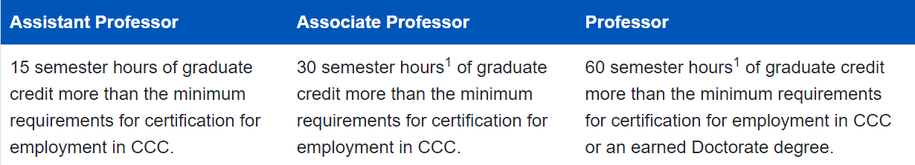

|  |  |  |  |  |
| --- | --- | --- | --- | --- |
| Degree-Level | Institution | Sem Hours Earned OR Degree Earned | Degree Completed? | Date Awarded |
| Bachelor’s Degree |  |  |  |  |
| Master’s Degree |  |  |  |  |
| Doctorate Degree |  |  |  |  |

*\*If more lines are needed, please include in Appendix B*

*\*****Transcripts must be included in Appendix B*** *for ANY degree that was earned following the applicant’s date of hire with CCC.*

## Professional Growth

List additional education (graduate semester hours/CEU’s) that will be used to fulfill the education requirements for this promotion application.

|  |  |  |
| --- | --- | --- |
| Institution/Agency | Type of credit (SH/CEU) | Number of Hours* |
|  |  |  |
|  |  |  |
|  |  |  |
|  |  |  |

***\*Documentation (transcripts/CEU reports) must be included in Appendix B  
\**** *Please note that quarter hours must be converted to semester hours: quarter hours x .666 = semester hour equivalent; 10 CEUs=1 graduate SH*



## Additional Experience

If applicable, please include in **Appendix B** a narrative describing the additional professional development or growth experience, the rational for the consideration of this experience, and any additional documentation the committee may need to consider the relevancy of the experience to Promotion in Rank.

# Evaluation of Performance in Teaching (classroom and non-classroom)

In **Appendix C**, include a narrative (minimum of 3 double-spaced, typewritten pages) describing in detail your classroom or library performance and techniques which enhance student educational growth and development. Focus on your procedures, abilities, creativity, motivational techniques, and use of technology that make you an excellent teacher or librarian. The following is provided for your guidance.

* **Mastery of the Subject Matter** (incorporate a minimum of 3 components from this category)
  + Knowledge of subject taught and of changes in applied aspect of specialty
  + Interest in subject taught
  + Academic breadth and perspective: ability to relate subject matter taught to broader areas
  + Presentation of subject matter relevant to student needs
  + Competence in the application of subject matter
* **Classroom Technique and Performance** (incorporate a minimum of 3 components from this category)
  + Make clear in measurable terms the course objectives, student learning outcomes, and requirements for grades
  + Meet the class promptly, regularly, and responsibly
  + Organize the course and prepare adequately for each class
  + Make a clear and intelligible presentation of subject matter
  + Illuminate subject matter through concrete illustrations, pertinent subsidiary information, applications to practical situations, etc.
  + Stimulate lively, well-directed discussions
  + Arouse student interest in subject matter and stimulate independent thought and effort
  + Make course content relevant to the student
  + Adjust teaching techniques and subject matter to the range of the class
  + Develop student ability to appreciate and to engage in critical thinking
  + Establish and maintain activities and interest which develop
  + effective communication with the student(s)
  + Use instructional technology effectively
  + Evaluate own performance as a teacher and make continuous improvements
  + *Optional -* Request classroom evaluation by an administrator
    - *Is this requested?* ______________

# Creative Teaching Methods

Describe any creative teaching techniques you use in your classroom, especially the commitment to integrating new technology (Use a separate sheet of paper.)

# College Service

**In Appendix D,** please provide a complete list and description of all district, college, and departmental activities in the last three years.

# Creative Productivity (publications, fellowships, awards, etc.)

# In Appendix E, please provide a detailed narrative of relevant activities that have occurred since the date of employment (if this is first promotion application) or the date of last promotion.

# Community or Other Service (reflecting service external to CCC)

|  |  |  |  |
| --- | --- | --- | --- |
| Service |  | Date |  |
| Service |  | Date |  |
| Service |  | Date |  |
| Service |  | Date |  |

# Professional Associations (current affiliations. Indicate offices held)

|  |  |  |  |  |  |
| --- | --- | --- | --- | --- | --- |
| Affiliation |  | Office Held |  | Date |  |
| Affiliation |  | Office Held |  | Date |  |
| Affiliation |  | Office Held |  | Date |  |
| Affiliation |  | Office Held |  | Date |  |
| Affiliation |  | Office Held |  | Date |  |

***Appendix A – Supplementary Information, Teaching Experience***

***Appendix B – Supplementary Information, Professional Experience***

***Appendix C – Evaluation of Performance in Teaching Narrative***

***Appendix D – College Service List***

***Appendix E – Creative Productivity Narrative***